**LEGAL ADVISSOR**

**INTRODUCTION**

In this project we provide all the official details of lawyers .In this we list the details of all the lawyers in the district ,display their rating ,how many cases they have won ,how to get their appointments and their charges. The rating of advocates are given based on the controversial cases

If a person logins to this site, he would get information about what all types of advocates are there .He can sort advocates based on their rating, their cases or fees charged by him .Also a person can chat with the lawyer .And in this we have included a special feature that is any person can view all the IPC section and check whether the case filed against them is genuine or not

Project approximately includes 6 modules .That is login, different types of advocates, sorting according to the user’s choice, and then displays the, details, take appointments and additional features.

**PROBLEM DEFINITION**

**2.PROBLEM DEFINITION**

LEGAL ADVISSOR is a pathetic company to work with, it better to hire a local CA, there services are poor then the Government office, at least in govt. we pay and get our file moved. LEGAL ADVISSOR is using the internet to simplify time-consuming paperwork. LEGAL ADVISSOR one-click access to individuals & business for all their legal and professional needs. The site, focusing on court related tasks like company registration, trademark registration and legal documentation.

LEGAL ADVISSOR is using the internet to simplify time-consuming paperwork. LEGAL ADVISSOR simplifies common legal matters for start-ups and growing companies by providing a wide range of services online and at affordable rates. Admin will make the interaction with government as smooth as is possible by doing all the paperwork for the users. The lawyers can view the appointments of users as well as he will get a notification alert as SMS in the time of user booking. The lawyers can responds to the questions which is asked by the users**.**

The proposed system minimize the drawbacks of the existing system to grate extend and make the task simply user friendly and more efficient for the user. It can be used to store different kinds of records or details. It has the facility for searching and viewing the details.

**SYSTEM STUDY**

**EXISTING SYSTEM**

A normal man does not have proper idea about what to do for a case. For legal help or clarifications people need to meet a lawyer directly. This is time consuming and difficult. Presently to meet a particular category lawyer like criminal lawyer user has to collect data manually. This can be solved in the proposed system.

**PROPOSED SYSTEM**

The proposed system is very helpful for ordinary people. The users will get all legal support through the site. The site will provide a list of registered lawyers and users can search them according to their needs like family lawyer, civil lawyer etc. and also can book lawyers online. The site will work like a agency for all legal supports. Lawyers can login to the site and checks for appointments. There is a special module for chatting between lawyer and users. Admin will receive the requests and he can do the further formalities for it.

**MODULE DESCRIPTION**

**Features**

The system comprises of 3 major modules with their sub-modules as follows:

1. **Admin:**
   1. **Login:** Admin can login into system using their valid credentials.
   2. **View Lawyer's Request:** New Lawyers who have been registered into the system will get the access after admin’s approval.
   3. **View Cases:** Admin can keep a look on the cases posted by user's and even delete them if found inappropriate.
   4. **View Users:** Registered users will be displayed to the admin with their details.
   5. **Edit / Delete User's:** Admin can edit or delete a user if required.
   6. **View Feedback:** Can view all the feedback’s received from the registered users.
   7. **Add IPC Section:** Can add all the IPC sections
2. **Advocate:**
   1. **Registration**: New lawyer need to register first with their basic registration details as well as qualification details.
   2. **Login:** Lawyer can login into the system once he/she is verified by the admin. Lawyer need to enter valid login credentials in order to access the system.
   3. **View Cases:** All the cases, which were raised by the user, will be displayed to the lawyer to learn every case. Lawyers can have a look on the cases posted by users, and they can have the case details and view any image if added. If they are interested in any of the case, he/she can write a message and send a request to a user.
   4. **View Accepted Request:** This section will have all the cases accepted by users, which was requested by the lawyer and then only the user’s details will be shown to the lawyer.
   5. **Send Feedback:** if a lawyer is facing any issue, he/she can send a feedback to admin.

**SYSTEM REQUIREMENTS**

**SYSTEM SPECIFICATIONS**

* 1. **Hardware Specification**

Processor : Intel core i3 and above

Memory : Minimum 1 GB RAM

Hard Disk Drive : 100 GB

Keyboard : QWERTY

Components : Scroll Mouse

Display : 14inch Colour Monitor

**3.2 Software Specification**

Operating System : Windows7 and above

Front End : Django Framework for PYTHON

HTML, JavaScript, CSS

Browser : Any One

IDE : Visual Studio Code

Back End : MYSQL

Documentation : Microsoft Word 2007

**Python**

Python is a dynamic, high level, free open source and interpreted programming language. It supports object-oriented programming as well as procedural oriented programming. In Python, we don’t need to declare the type of variable because it is a dynamic typed language. For example, x=10, here x can be anything such as String, int etc.

### Features in Python

There are many features in Python, some of which are discussed below –

**1. Easy to code:**

Python is high level programming language. Python is very easy to learn language as compared to other language like c, c#, java script, java etc. It is very easy to code in python language and anybody can learn python basic in few hours or days. It is also developer-friendly language.

**2. Free and Open Source:**

Python language is freely available at official website and you can download it. Since, it is open-source, this means that source code is also available to the public. So you can download it as, use it as well as share it.

**3. Object-Oriented Language:**

One of the key features of python is Object-Oriented programming. Python supports object oriented language and concepts of classes, objects encapsulation etc.

**4. GUI Programming Support:**

Graphical Users interfaces can be made using a module such as PyQt5, PyQt4, wxPython or Tk in python.PyQt5 is the most popular option for creating graphical apps with Python.

**5. High-Level Language:**

Python is a high-level language. When we write programs in python, we do not need to remember the system architecture, nor do we need to manage the memory.

**6.Extensible feature:**

Python is an Extensible language. We can write some python code into c or c++ language and also we can compile that code in c/c++ language.

**7. Python is Portable language:**

Python language is also a portable language. For example, if we have python code for windows and if we want to run this code on other platform such as Linux, Unix and Mac then we do not need to change it, we can run this code on any platform.

**8. Python is Integrated language:**

Python is also an Integrated language because we can easily integrated python with other language like c, c++ etc.

**9. Interpreted Language:**

Python is an Interpreted Language. Because python code is executed line by line at a time. Like other language c, c++, java etc. there is no need to compile python code this makes it easier to debug our code. The source code of python is converted into an immediate form called bytecode.

**10. Large Standard Library:**

Python has a large standard library which provides rich set of module and functions so you do not have to write your own code for every single thing. There are many libraries present in python for such as regular expressions, unit-testing, web browsers etc.

**11. Dynamically Typed Language**

Python is dynamically-typed language. That means the type (for example- int, double, long etc.) for a variable is decided at run time not in advance. Because of this feature we don’t need to specify the type of variable.

**Django**

Django  is a [Python](https://en.wikipedia.org/wiki/Python_(programming_language)) based [free and open-source](https://en.wikipedia.org/wiki/Free_and_open-source_software) [web framework](https://en.wikipedia.org/wiki/Web_framework), which follows the model-template-view (MTV) [architectural pattern](https://en.wikipedia.org/wiki/Architectural_pattern_(computer_science)). Django's primary goal is to ease the creation of complex, database driven websites. The framework emphasizes [reusability](https://en.wikipedia.org/wiki/Reusability) and pluggability of components, less code, low coupling, rapid development, and the principle of [don't repeat yourself](https://en.wikipedia.org/wiki/Don%27t_repeat_yourself). Python is used throughout, even for settings files and data models. Django also provides an optional administrative [create, read, update and delete](https://en.wikipedia.org/wiki/Create,_read,_update_and_delete) interface that is generated dynamically through [introspection](https://en.wikipedia.org/wiki/Type_introspection) and configured via admin models.

Despite having its own nomenclature, such as naming the callable objects generating the [HTTP](https://en.wikipedia.org/wiki/HTTP) responses views, the core Django framework can be seen as an [MVC](https://en.wikipedia.org/wiki/Model-view-controller) architecture. It consists of an [object-relational mapper](https://en.wikipedia.org/wiki/Object-relational_mapping) (ORM) that mediates between [data models](https://en.wikipedia.org/wiki/Data_modeling) (defined as Python classes) and a [relational database](https://en.wikipedia.org/wiki/Relational_database) (Model), a system for processing HTTP requests with a [web templating system](https://en.wikipedia.org/wiki/Web_template_system) (View), and a [regular-expression](https://en.wikipedia.org/wiki/Regular_expression)-based [URL](https://en.wikipedia.org/wiki/Uniform_Resource_Locator) dispatcher (Controller).

Also included in the core framework are:

* A lightweight and standalone web server for development and testing.
* A form serialization and validation system that can translate between [HTML](https://en.wikipedia.org/wiki/HTML) forms and values suitable for storage in the database.
* A template system that utilizes the concept of [inheritance](https://en.wikipedia.org/wiki/Inheritance_(object-oriented_programming)) borrowed from object-oriented programming.
* A [caching](https://en.wikipedia.org/wiki/Web_cache) framework that can use any of several cache methods
* Support for [middleware](https://en.wikipedia.org/wiki/Middleware) classes that can intervene at various stages of request processing and carry out custom functions
* An internal dispatcher system that allows components of an application to communicate events to each other via pre-defined signal.
* An [internationalization](https://en.wikipedia.org/wiki/Internationalization_and_localization) system, including translations of Django's own components into a variety of languages
* A [serialization](https://en.wikipedia.org/wiki/Serialization) system that can produce and read [XML](https://en.wikipedia.org/wiki/XML) and/or [JSON](https://en.wikipedia.org/wiki/JSON) representations of Django model instances
* A system for extending the capabilities of the template engine
* An interface to Python's built-in [unit test](https://en.wikipedia.org/wiki/Unit_test) framework
* Django REST framework is a powerful and flexible toolkit for building Web APIs

**Java Script**

Java script is a scripting language that can be used to create client-side scripts and server side scripts. Client-side scripts are executed in the browser while server-side scripts are executed on a server. That is JavaScript is an object-based scripting language for developing client based and server-based internet applications. We can insert JavaScript statements directly into an HTML page. When the page is displayed in the browser, the JavaScript statements are interpreted and executed by the browser. JavaScript statements can recognize and respond to user events such as mouse clicks or system generated events and so on. So you can change the content and position of the elements on the page dynamically, in response to user interaction.

When the client requests an HTML page that includes a client-side Script, the server forwards the full content of the HTML document- the JavaScript statements and the HTML content. When the browser receives the document, it executes the HTML and JavaScript statements without any interaction with the server while both client-side JavaScript and server-side JavaScript have the same core language; each also has additional features relevant to the environment. That is, client-side JavaScript includes predefined objects that can be used only in the browser. Server-side JavaScript contain predefined objects that can be used in server-side application

**Hyper Text Mark Up Language**

An HTML file is a text file containing small markup tags. These tags tell the web browser how to display the page. An HTML file must have an htm or html file extension. An HTML file can be created by using a simple text editor. HTML documents are text files made up of HTML elements e.g.: <html>, <body>. HTML elements are defined using HTML tags.

HTML tags are used to markup HTML elements. The two characters surround HTML tags <and>. The surrounding characters are called angle brackets. HTML tags normally come in pairs like <b> and </b>. The first tag in a pair is the start tag: the second tag is the end tag. The text between the start and the end tag is the element content. HTML tags are not case sensitive; <b> means the same as <B>.

**MySQL**

Relational database systems are the most important database systems used in the software industry today. One of the most outstanding systems is MySQL.

The important aspects of SQL Server are:

* MySQL is easy to use.
* Embedded database library.
* Commit grouping, gathering multiple transactions from multiple connections together to increase the number of commits per second.

MySQL is a popular choice of database for use in web applications, and is a central component of the widely used [LAMP](https://en.wikipedia.org/wiki/LAMP_(software_bundle)) open source web application software stack (and other "[AMP](https://en.wikipedia.org/wiki/List_of_AMP_packages)" stacks). LAMP is an acronym for "[Linux](https://en.wikipedia.org/wiki/Linux), [Apache](https://en.wikipedia.org/wiki/Apache_HTTP_Server), MySQL, [Perl](https://en.wikipedia.org/wiki/Perl)/[PHP](https://en.wikipedia.org/wiki/PHP)/[Python](https://en.wikipedia.org/wiki/Python_(programming_language))." [Free-software](https://en.wikipedia.org/wiki/Free_software)-open source projects that require a full-featured database management system often use MySQL.

On all platforms except Windows, MySQL ships with no [GUI](https://en.wikipedia.org/wiki/Graphical_user_interface) tools to administer MySQL databases or manage data contained within the databases. Users may use the included [command line](https://en.wikipedia.org/wiki/Command_line) tools, or install [MySQL workbench](http://dev.mysql.com/downloads/workbench/) via a separate download. Many third-party GUI tools are also available.

**DATA FLOW DIAGRAM**

A DFD, also known as a “bubble chart” has the purpose of clarifying system requirements and identifying major transformations that will become programs in system design. A DFD consists of a series of bubbles joined by lines. The bubbles represents data transformations and the lines represents data flow in the system. A data flow diagram may be used to represent a system or software at any level of abstraction. A DFD is a diagram that describes the flow of data and the processes that change or transform data throughout a system. It is a structured analysis and design tool that can be used or flowcharting in place of, or in association with, information oriented and process oriented system flowchart. When analyst prepare the DFD, they specify the user needs at a level of detail that virtually determines the information flow into and out of the system and the required data resources. This network is constructed by using a set of symbols that do not imply a physical implementation. The DFD reviews the current physical system, prepare input and output specification, specifies the implementation plan etc.

Basic data flow diagrams symbols are:

- A “Rectangle” defines a source or destination destination of a system data

- An “Arrow” identifies data flow. It is a

pipeline through which information flows.

* A “circle “ represents a process that transforms incoming data flow(s) into outgoing data flow(s).

* An “open rectangle” is a data store.

Steps to construct Data Flow Diagram

Four steps are commonly used to construct a DFD

* Process should be named and numbered for easy reference. Each name should be representative of the process.
* The direction of flow is from top to bottom and from left to right.
* Then a process is exploded in to lower level details they are numbered

**DATA FLOW DIAGRAM**

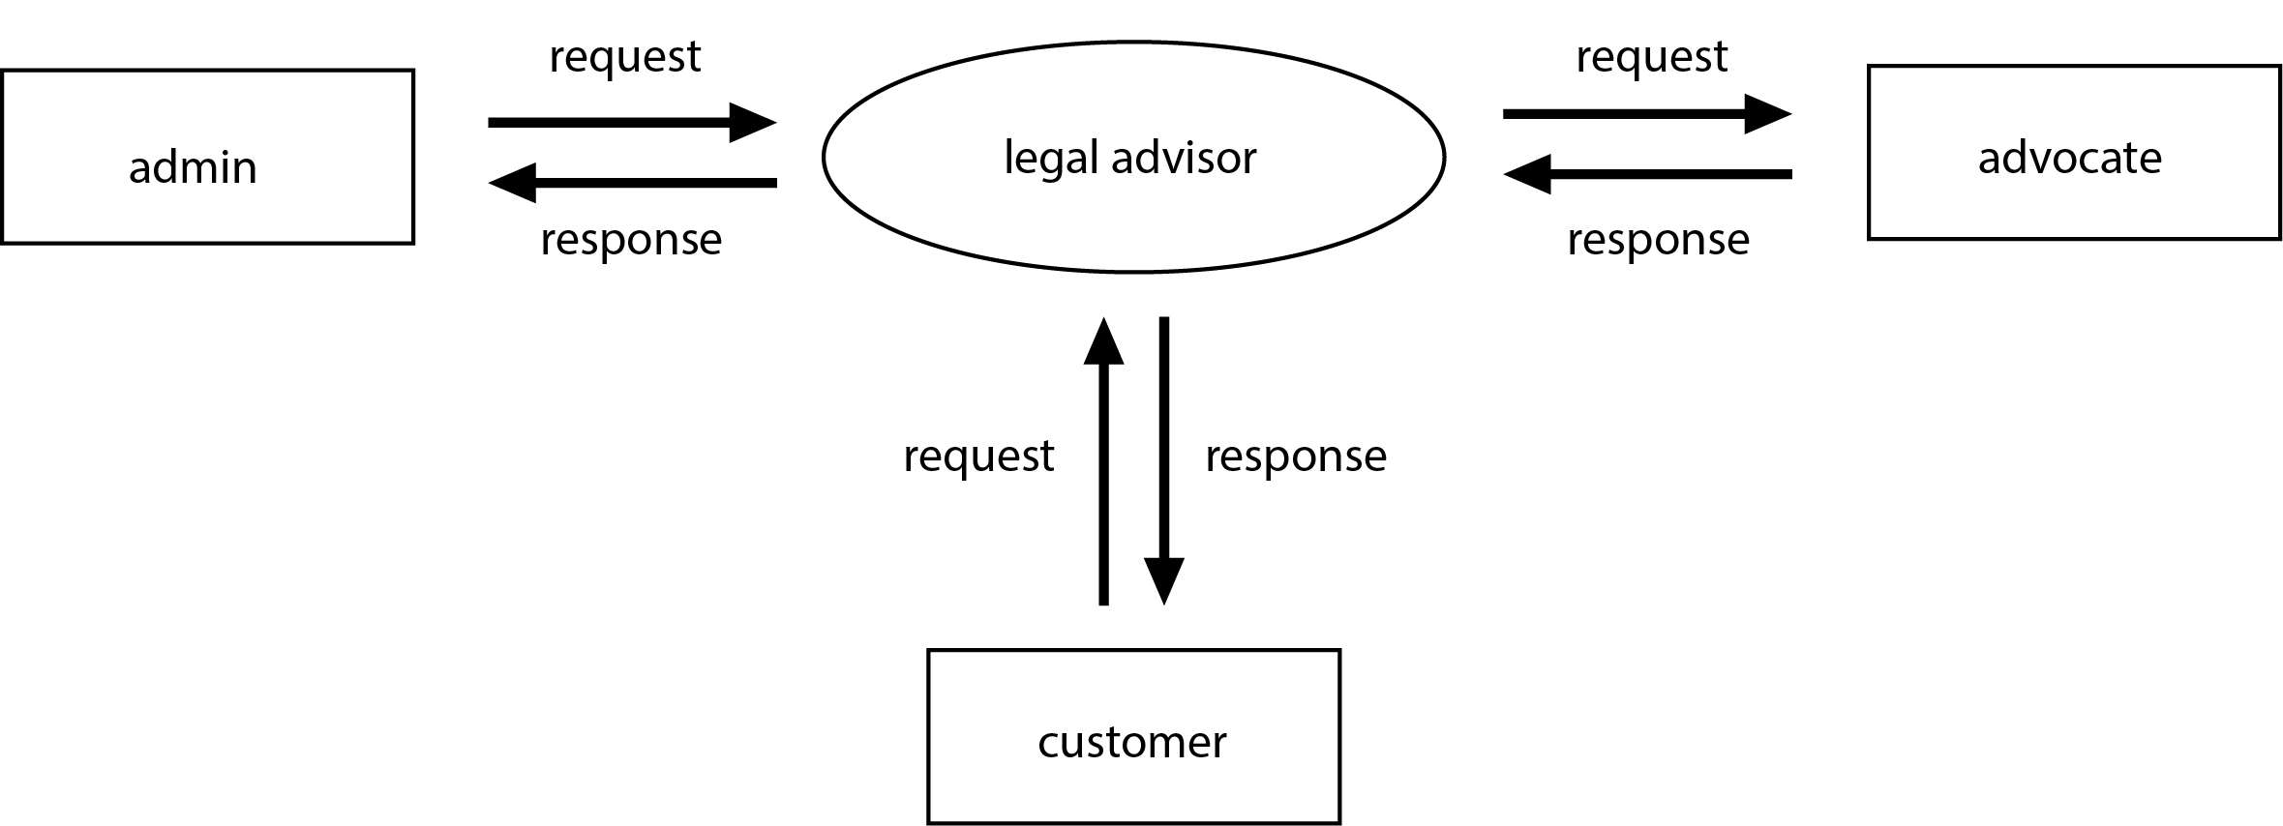

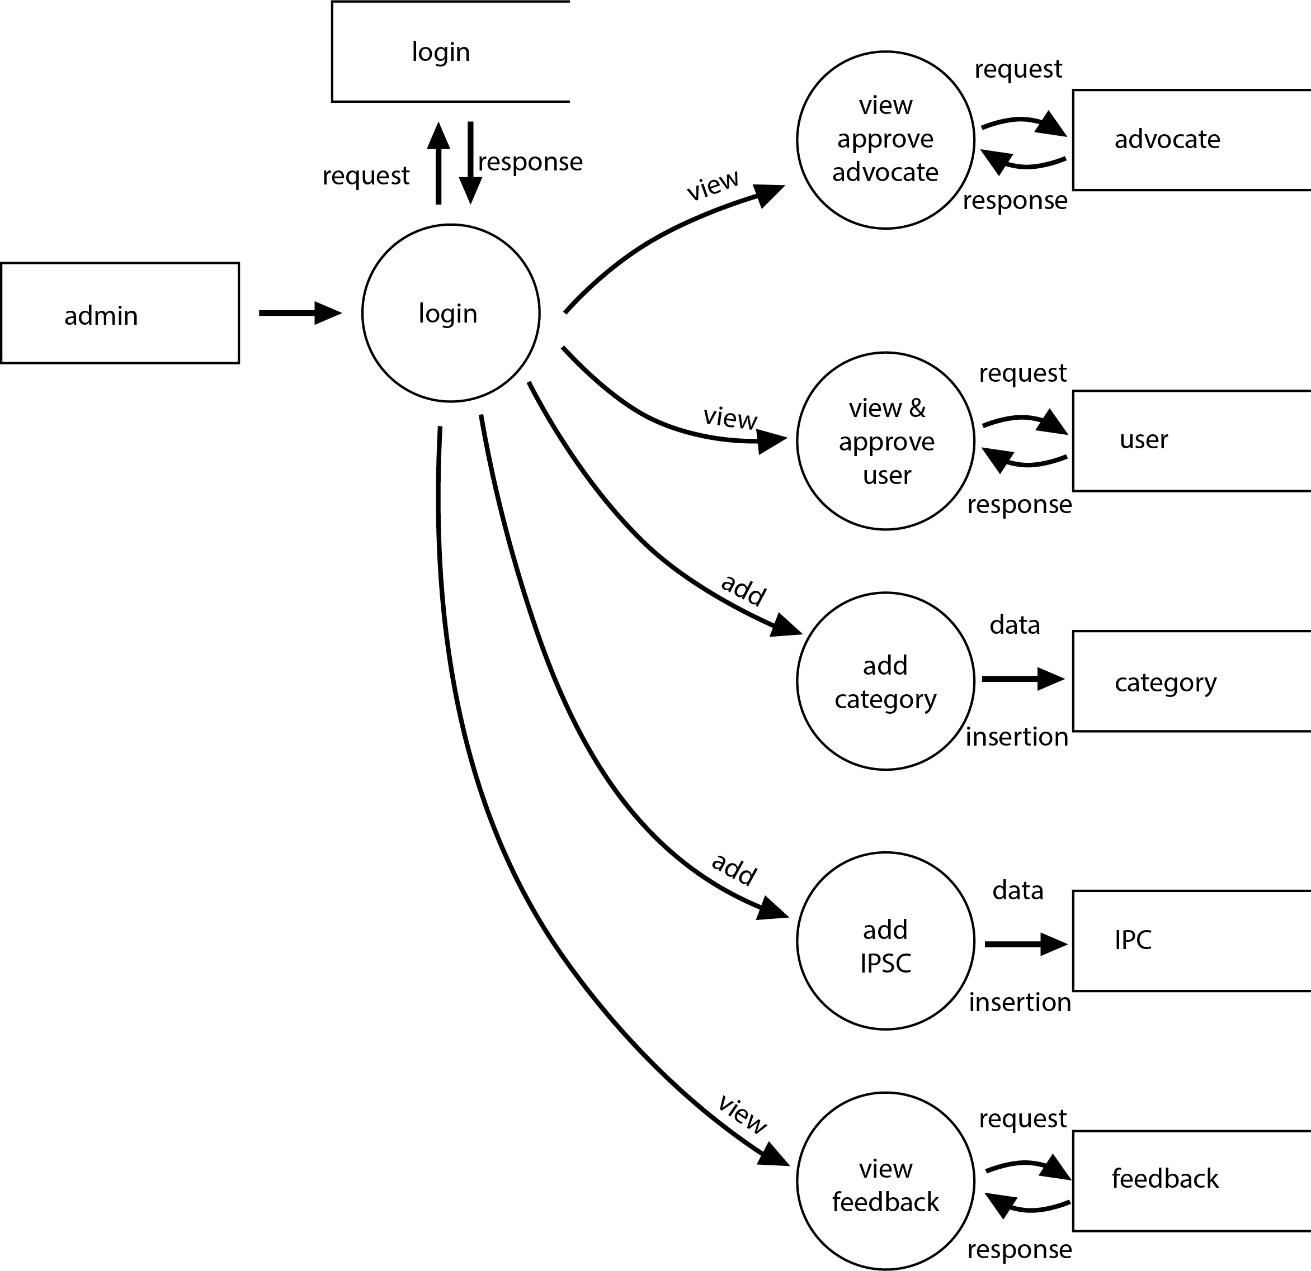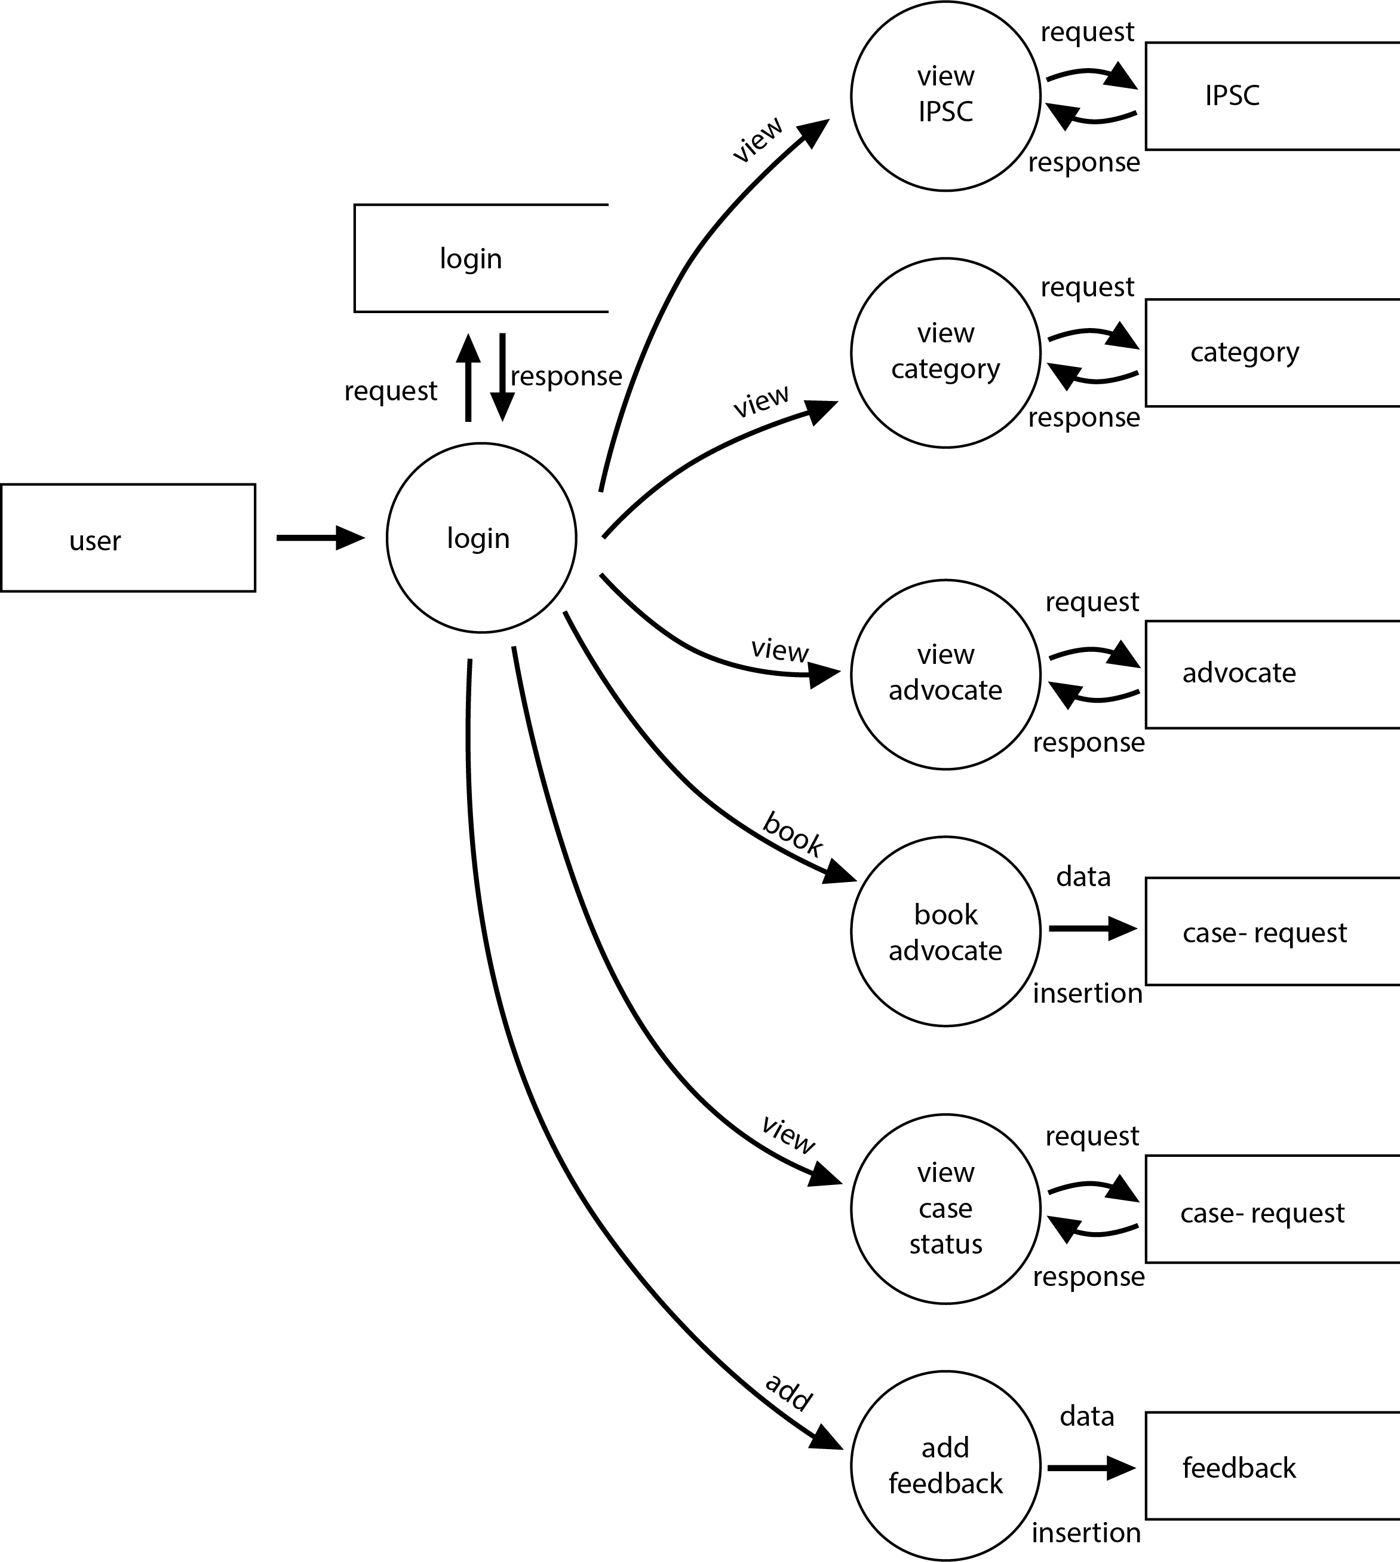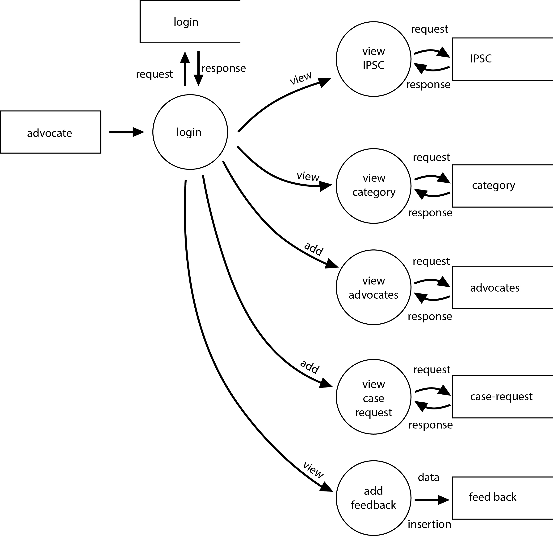

**TABLE**

**LEGAL ADVISOR TABLES**

1.

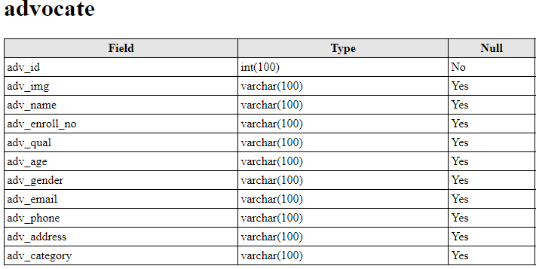

2.

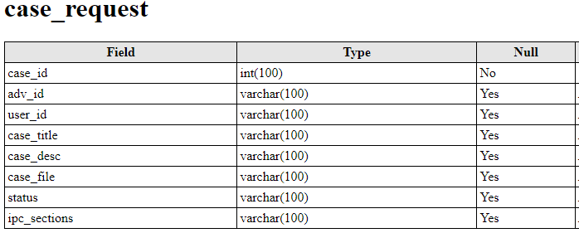

3.

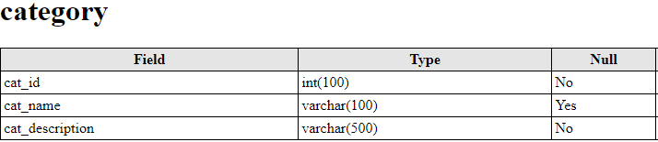

4.

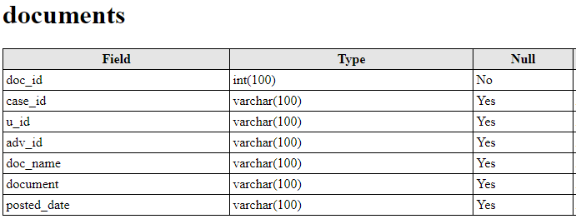

5.

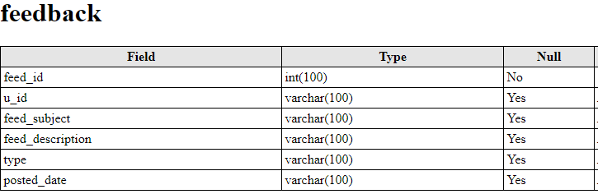

6.

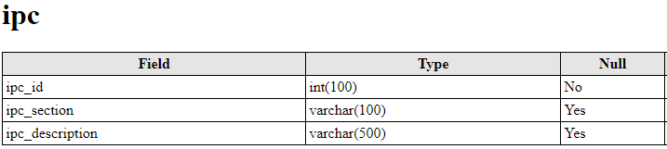

7.

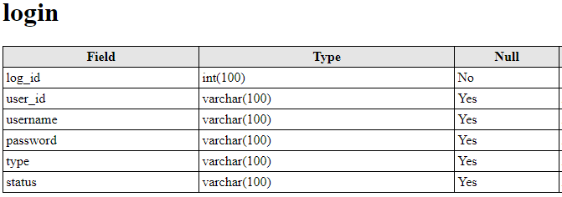

8.

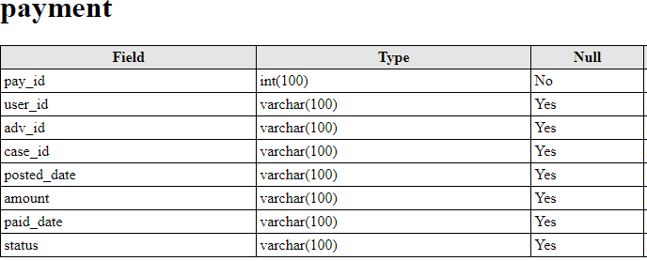

9.

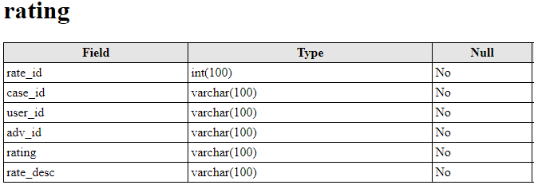

10.

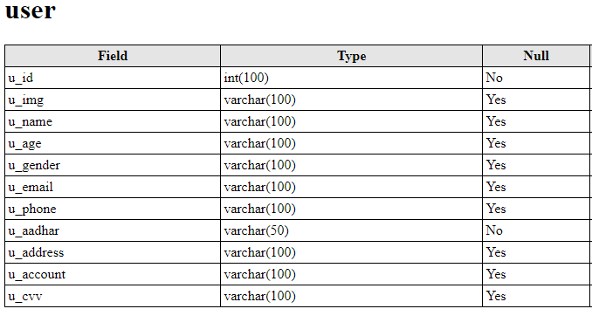

# SYSTEM DESIGN

The most creative and challenging phase of the system development

process is system design. It is the solution to the creation of the proposed system. It refers to the technical specification that will be applied. It provides the understanding and procedural details necessary for implementing the system recommended in the feasibility study. Detailed design specification describes the features of the system, input output files and data files. The system meets its requirements in terms of presenting proper form of information, providing accurate results, using appropriate method of interaction and providing overall reliability.

Design and specification of the system are in accordance with prescribed rules and practice.

The system design phase includes

* Input Design
* Output Design
* Database Design

##### 5.1 INPUT DESIGN

The system design process is not a step-by-step adherence of clear procedures and guidelines. Anyway the design phase focuses on the detailed implementation of the system recommended in the feasibility study. The design phase is a transition from a user oriented document to a document oriented programmers or database personnel. Inaccurate input data is the most common cause of errors in data processing. Errors entered by data entry operations can be controlled by input design. Input design is the process of converting user oriented inputs to computer based format. It includes the determining of record media, the method of input, speed of capture and entry into the system

**Major Input Screen:**

The following are the major output screens used.

* Login

The input screen is used for logging into the system by providing username and password

* Add Advocate

The function will help to Add new Advocate

* Add case Details

The customer is responsible for add the case details into the database

* Update Case Details

The advocate is responsible for updating the case details into the database

##### 5.2 OUTPUT DESIGN

Designing the output should proceed in well thought out manner. The term output means any information produced by the information system whether printed or displayed. Output design is a process that involves designing necessary outputs that have to be used by various users according to requirement. The efficient intelligent output design should remove the system relationship with the users and help in decision making.When designing the output, system analyst must accomplish the following:

* Determine the information present.
* Decide whether to print, display the information and select output medium.
* Arrange information in acceptable format.

**Major Output Screen:**

The following are the major output screens used.

* view case details

Advocate, customer can view the case details

* view case status details

customer can view the case status details

* view feedback details

Admin, customer can view the feedback details

##### 5.3 DATABASE DESIGN

A database is a collection of information and is systematically stored in tables in the form of rows and columns. The table in the database has unique name that identifies its contents. The database in turn is further described in detail giving all the fields used with the data types, constraints available, primary key and foreign key.

Database design is used to manage large bodies of information. In this database we describe all the 4 tables available in the software, which are used to store all the records. For developing an effective database, we will have to fulfill certain condition such as

* Control Redundancy
* Ease Of Use
* Data Independence
* Accuracy and Integrity
* Privacy and Security
* Performance

### Data types and its description:

Fields in database table have a data type. Some of the data types used in database table are explained below.

1. Integer:-

One optional sign character (+ or -) followed by at least one digit (0-9). Leading and trailing blanks are ignored. No other character is allowed.

1. Varchar:-

It is used to store alphanumeric characters. In this data type we can set the maximum number of characters up to 8000 ranges by default SQL server will set the size to 50 characters large.

1. Date/Time:-

Date/Time data type is used for representing data or time. d) Float:-

Float data type is used for representing floating point values.

### Normalization:

Normalizations usually thought of as a process of applying a set of rules to

your database design, mostly to achieve minimum redundancy in the data. Most textbooks present this as a three-step process, with correspondingly labeled “normal forms” which could be done in an algorithmic sequence.

* **First normal form (1NF):**1NF sets the very basic rules for an organized database:
  + Eliminate duplicative columns from the same table.
  + Create separate tables for each group of related data and identify each row with a unique column or set of columns (the primary key).
* **Second normal form (2NF):**2NF further addresses the concept of removing duplicative data:
  + Meet all the requirements of the 1NF.
  + Remove subsets of data that apply to multiple rows of a table and place them in separate tables.
  + Create relationships between these new tables and their predecessors through the use of foreign keys.
* **Third normal form (3NF):**3NF goes one large step further:
  + Meet all the requirements of the 2NF.
  + Remove columns that are not dependent upon the primary key.

# SYSTEM IMPLEMENTATION ANDMAINTENANCE

The implementation stage of the project is where the theoretical design is tuned into working system. At this stage the main workload, the greatest up heal and major impact or existing practices shifts to the user department. Thus it can be considered to be the most critical stage in achieving a successful new systems and in giving the users confidence that the new system will work and be effective.

The implementation stage involves careful planning, investigation of the current system and its constraints on implementation, design of method to achieve the changeover, training of staff in the changeover procedures and evaluation of the changeover method. The change over may be achieved in a number of ways.

As we know, creating software is one thing and the implementation of the created software is another. The process of implementing software is much difficult as compared to the task of creating the project. First we have to implement the software on a small scale for removing the bugs and other errors in the project and after removing them we can implement the software on a large scale. Before we think in terms of implementing the Software on a large basis, we must consider the Hardware requirements.

Whenever develop software or project, a certain hardware and software is being used by the programmer for developing the project. The hardware and software to be used by the programmer for developing the project should be such that it would result in the development of a project, which would satisfy all the basic needs for which the project has been created by the programmer. The Hardware should be such that cost constraints of the Client should also be taken into account without affecting the performance.

# 7. SYSTEM TESTING

Software testing is an empirical investigation conducted to provide stakeholders with information about the quality of the product or service under test, with respect to the context in which it is intended to operate. Testing also provides an objective, independent view of the software to allow the business to appreciate and understand the risks at implementation of the software. Test techniques include, but are not limited to, the process of executing a program or application with the intent of finding software bugs. It can also be stated as the process of validating and verifying that a software program/application/product meets the business and technical requirements that guided its design and development, so that it works as expected and can be implemented with the same characteristics.

Software Testing, depending on the testing method employed, can be implemented at any time in the development process, however the most test effort is employed after the requirements have been defined and coding process has been completed.

##### 7.1 TESTING TECHNIGUES

Testing technique refers to the different methodologies followed during testing. There are basically two types of techniques followed in software testing.

1. **Static testing:** In static testing the program is not run or executed for testing purpose. Here basically involves some informal approaches of testing. Static testing involves code reviews, code reading, code walkthroughs etc.
2. **Dynamic testing:** In dynamic testing the program or software is executed and tested with test data. The program is traced and debugged. Here there exist two types of testing namely black box testing and white box testing.

##### 7.2 DIFFERENT LEVELS OF TESTING

### • Unit Testing:

It is the first level of testing. Each module is tested individually and focus is given for finding errors limited to each individual module and correcting them. The different modules of the system are tested individually and corrected all errors. Each module is focused to work satisfactorily with regard to the expected output from the module. In [computer programming,](https://en.wikipedia.org/wiki/Computer_programming) Unit testing is successfully tested in our system .As an example code fragmentation of registration of branch by the admin module and adding hospital details admin are successfully tested.

### • Integrated System Testing:

Integration testing (sometimes called integration and testing, abbreviated I&T) is the phase insoftware testin[g](https://en.wikipedia.org/wiki/Software_testing) in which individual software modules are combined and tested as a group. Consider our system, Hospital module is first register with their details, which can be successfully viewed by the admin. This Communication flow is correctly implemented.

• **Validation Testing:**

For each input forms validation testing are done to ensure that only allowed values will be entered. Entering incorrect values does the validation testing and it is checked whether the errors are being considered. Incorrect values are to be discarded.

Eg: Consider doctor module in our system, doctor can register their details in registration form. Registration form consist of some filed i.e username, contact number, gender, profile picture etc, if they try to skip any filed then click the signup button ,in this case validation will perform. This is the one type of validation.

### • Output Testing:

After performing the validation testing, the next step is output testing of the proposed system, since no system could be useful if it does not produce the required output in the specific format. The output generated by the system under considerations is tested by asking the users about the format required by them.

**SYSTEM SECURITY MEASURES**

The protection of computer based resources that includes hardware, software, data, procedures and people against unauthorized use or natural Disaster is known as

System Security.

System Security can be divided into four related issues:

• Security

• Integrity

• Privacy

• Confidentiality

System **security** refers to the technical innovations and procedures applied to the hardware and operation systems to protect against deliberate or accidental damage from a defined threat. Data security is the protection of data from loss, disclosure, modification and destruction.

System **integrity** refers to the power functioning of hardware and programs, appropriate physical security and safety against external threats such as eavesdropping and wiretapping.

**Privacy** defines the rights of the user or organizations to determine what information they are willing to share with or accept from others and how the organization can be protected against unwelcome, unfair or excessive dissemination of information about it.

**Confidentiality** is a special status given to sensitive information in a database to minimize the possible invasion of privacy. It is an attribute of information that characterizes its need for protection.

Complex and distributed critical infrastructures usually spread over large geographic areas, different parts of those infrastructures have different levels of perimeter defines. Devices in weakly protected zones are more likely to be captured than those in well protected zones. If an adversary captures devices, s/he can bypass cyber security measures and obtain secret information directly. Such a threat requires a layered security mechanism that can prevent adversaries from invading the whole infrastructure network from these weak zones. The main

feature of this system is providing security to network. The system itself is a security mechanism based on hash chain technology for securing data in a layered manner

Physical:

This system is physically secured against arms or surreptitious entry by intruders.

This approach prevents data from being eavesdropped, tampered with, or forged.

Operating System:

No matter how to secure the system is, weakness in operating system security may serves as a means of unauthorized access to the network. Here Windows 8.1 as an operating system provides better level of

Security Network:

Since almost all network system allows remote access through terminals and networks, software –level security within the network software is important. Network security can be attained by setting firewall and security options available with windows.

**SCOPE FOR FUTURE ENHANCEMENT**

In future since each and every application should expand and it should provide a way for updating the system has been developed. All modules in the system is being developed carefully such that the future enhancement does not affect the basic performance of the system. The main enhancements of the project is:

* To encrypt files that are attached by the user
* To use multiple encryption algorithms
* Considering about creating a mobile application.

# CONCLUSION

The relevance of the project is clear, since the implementation of the system is very easy. Even though the computer and its applications are rapidly becoming popular, only a few established organization, companies and educational institutions are automatic the system. The others just continue with the old type of processing, which is the manual system.

The new system “Legal Advissor” thus obtains the full certificate of achievements in handling all users with full satisfaction. A trial run of the system has been made and is giving good results.

**BIBLIOGRAPHY**

* Roger S Pressman – Software Engineering
* Pankaj Jalote, ― An Integrated approach to Software Engineering
* Abraham Silberschatz, ― Database System Concepts
  + Ramez Elmasri , Shamkant &B.Navathe― Introduction to Data Base Management system

**WEBLIOGRAPHY**

* http://www.wikipedia.com/
* http://www.stackoverflow.com/
* http://w3schools.com/
* http://www.tutorialpoint.com/
* http://www.w3layouts.com/